

**PROJECT REPORT**

# Project Name

|  |  |
| --- | --- |
| **Semester:** | Programming Fundamentals |
| **Class:** | PFXX |
| **Group:** | Group Name |
| **Instructor** | Instructor_Name |
| **Team members:** | StudentId – Student_Name_1  StudentId – Student_Name_2  StudentId – Student_Name_3 |

# Index

Project Name 1

Index 2

I. Project introduction 3

II. Analyze System Requirements 3

III. Design Details 8

IV. Test 14

V. Task Assign (to each team member) 15

VI. Installation Instructions 16

Appendix 17

Document format 18

# Project introduction

Briefly describe the operation of the system to which the project will be applied

...

1. Proposed System

...

1. The scope of the project to be applied

...

1. System Name

...

1. Deployment Environment

...

1. Development Tools

...

1. Customer Requirements (System features)
   1. Functional Requirements
   2. External Interface Requirements
   3. System Features
   4. Nonfunctional Requirements

# Analyze System Requirements

< Specify the requirements of the system required to meet customer requirements. This is the content of the discussion presented in more detail >

1. Use Case

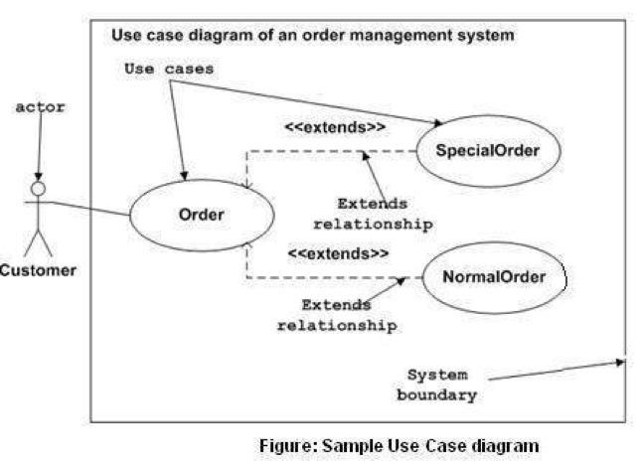

|  |  |
| --- | --- |
| Use Case Name | The Use Case name. Typically the name is of the format <action>+<object> |
| Use Case ID | An identifier that is unique to each Use Case |
| Description | A brief sentence that states what the user wants to be able to do and what benefit he will derive |
| Actor | The type of user who interacts with the system accomplish the task. Actors are identified by role name. |
| Organizational Benefits | The value the organization expects to receive from having the functionality described. Ideally this is a link directly to a Business Objective |
| Triggers | Concrete actions made by the user within the system to start the Use Case. |
| Preconditions | Any states that the system nmust be in or conditions that must be met before the Use Case is stated |
| Postconditions | Any states that the system must be in or conditions that mus be met after the Use Case is completed successfully. These will be met if the Main Course or any Alternate Course are followed. Some Exceptions may result in failure to meet the Posconditions. |
| Main Course | The most common path of interactions between the user and the system  1. Step 1  2. Step 2 |
| Alternate Courses | Alternate paths through the system  AC1: <condition for the alternate to be called>  1. Step 1  2. Step 2  AC2: <condition for the alternate to be called>  1. Step 1  2. Step 2 |
| Exceptions | Exception handling by the system  EX1: <condition for the exception to be called>  1. Step 1  2. Step 2  EX1: <condition for the exception to be called>  1. Step 1  2. Step 2 |

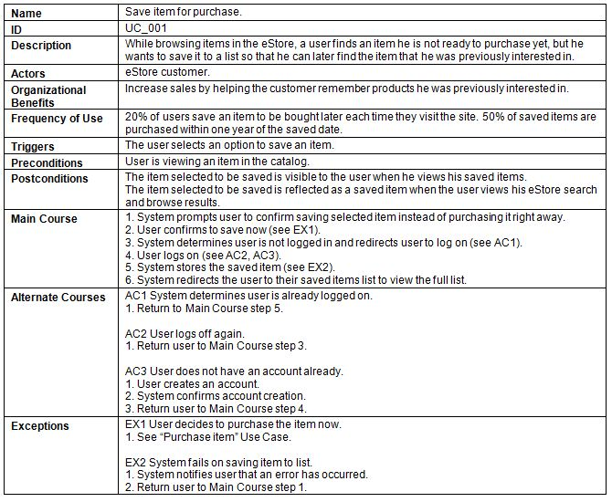

1. Activity Diagram:

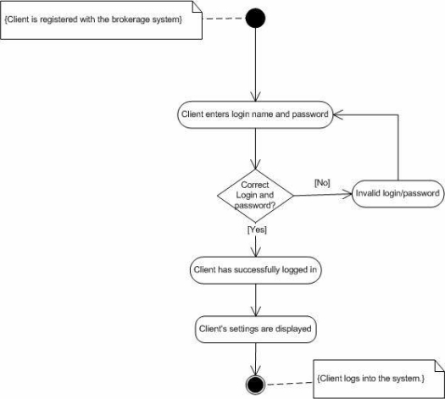

# Design Details

1. UI Design

< Design the main user interface and for each features of the software >

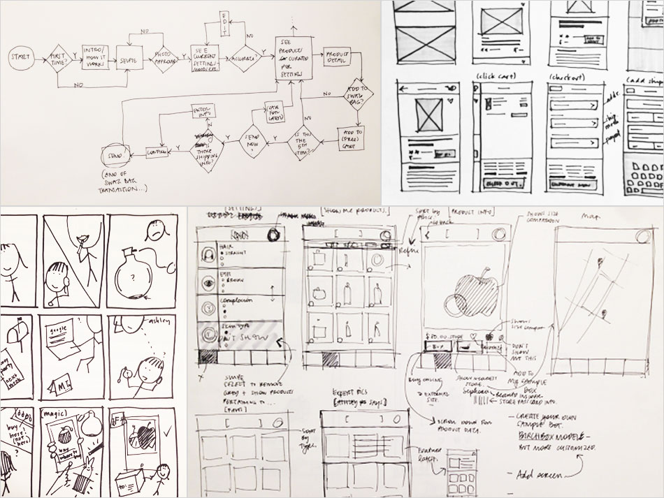

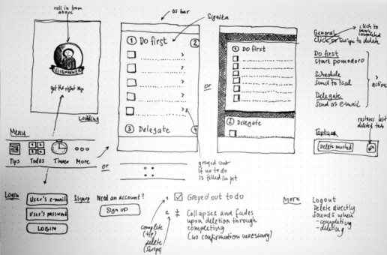

1. Code Design (Class Diagram)

(Class Diagram):

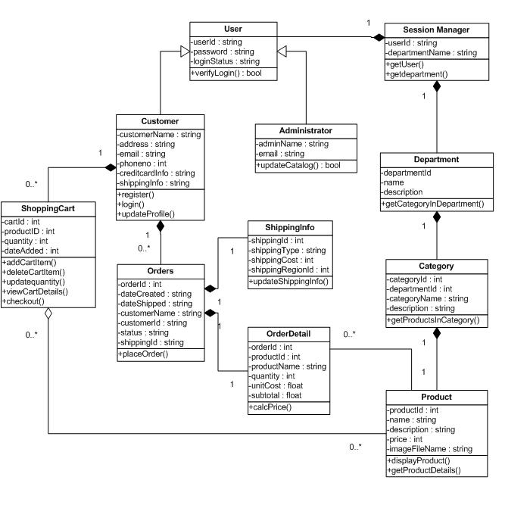

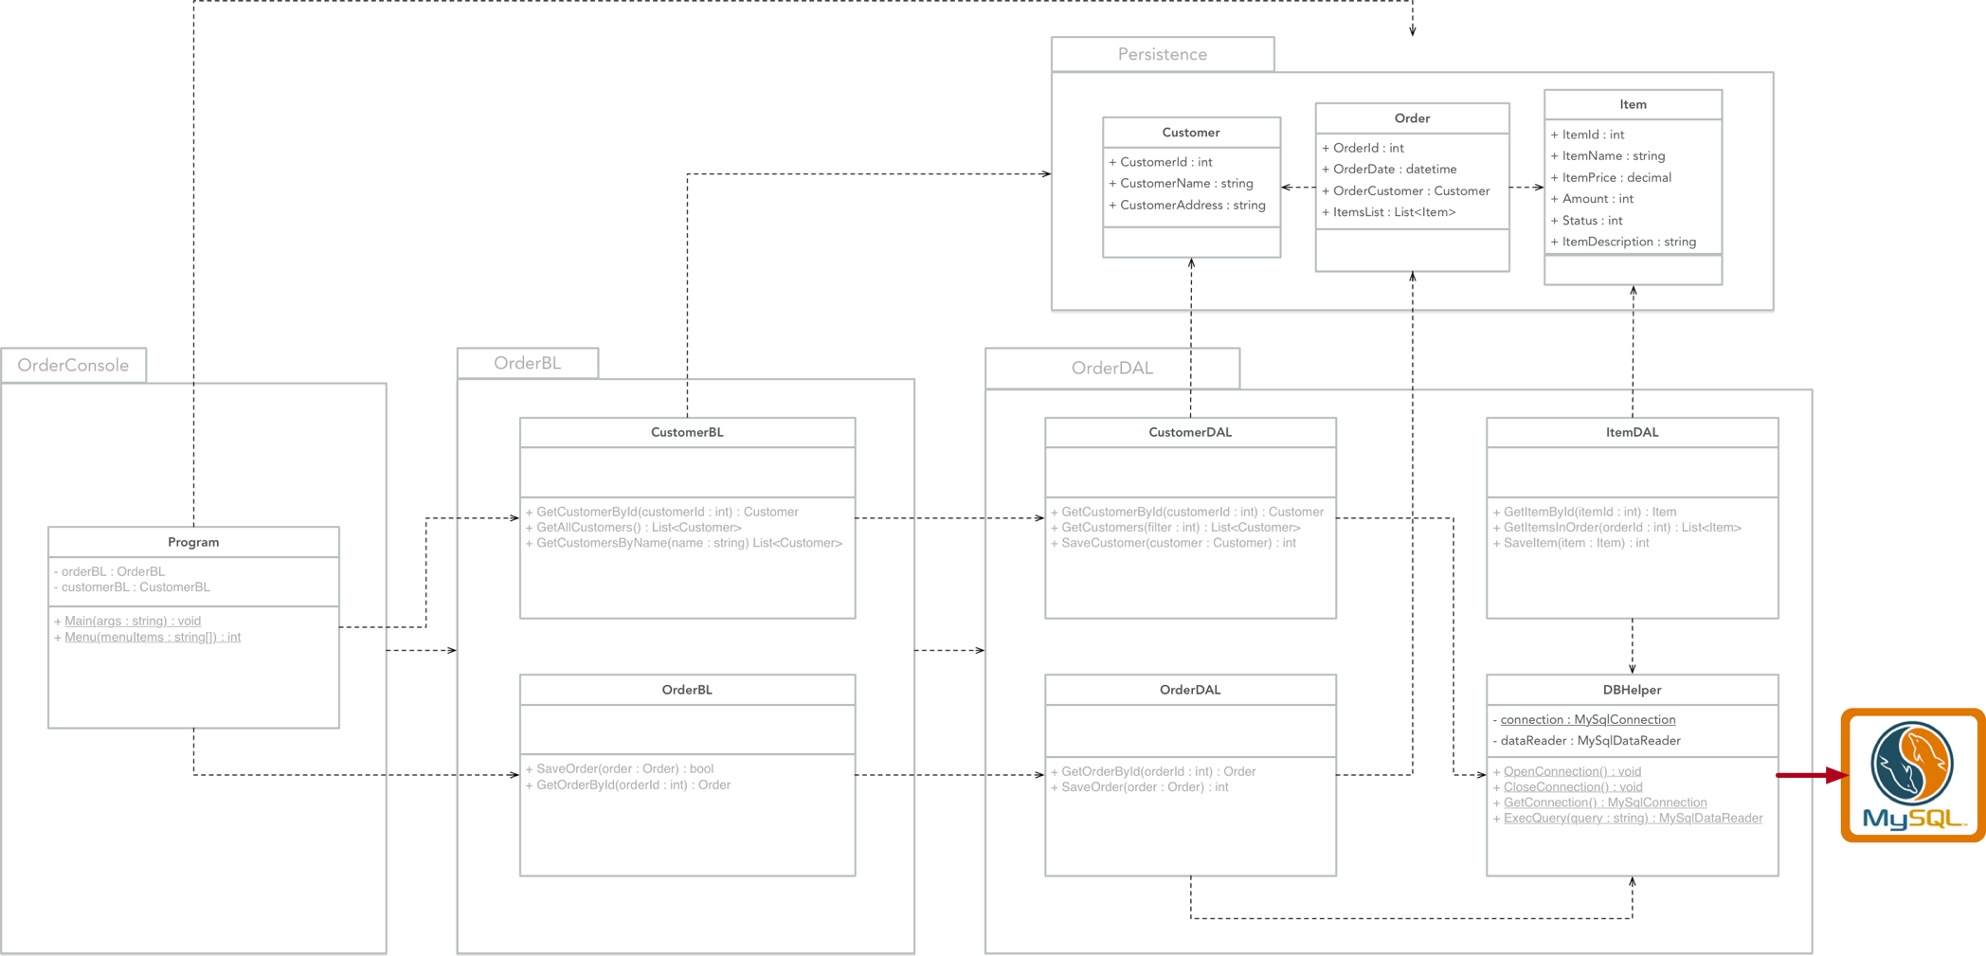

1. Sequence Diagram

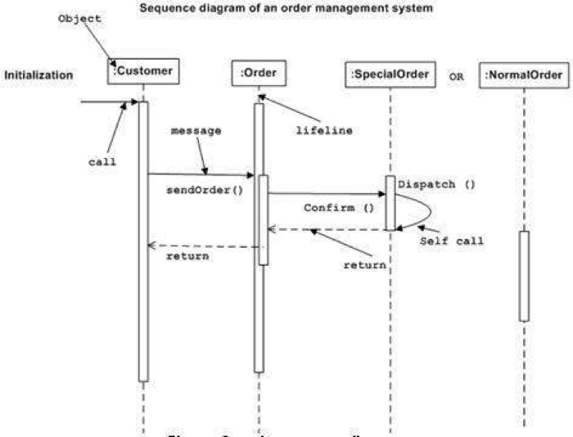

1. Database Design
   1. Entity Relationship Diagram

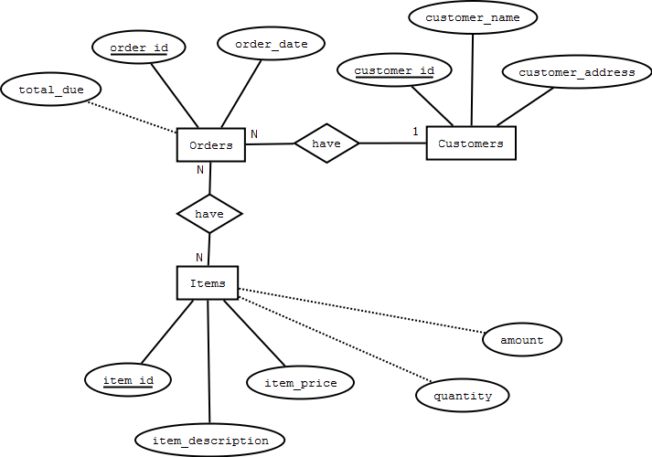

Or

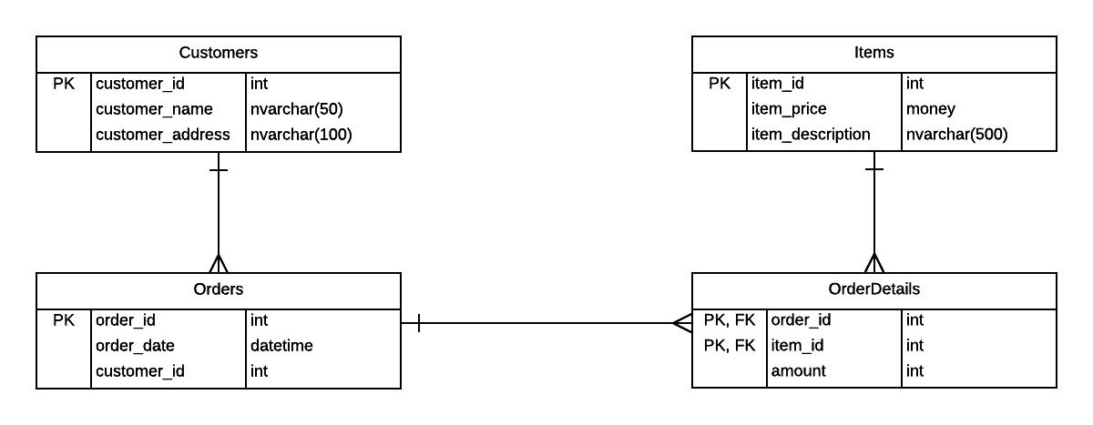

* 1. Database Design Details

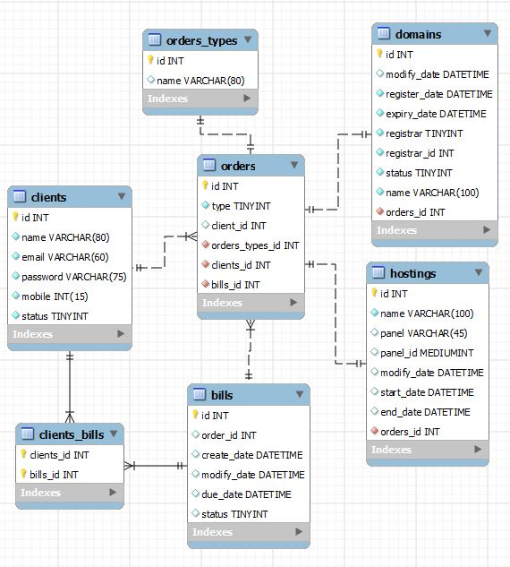

|  |  |  |  |
| --- | --- | --- | --- |
| Users | | | |
| Column Name | Data Type | Constraints | Description |
| UserID | int | Primary Key, Autoincrement |  |
| UserName | varchar(50) | NOT NULL |  |
| UserPassword | varchar(50) | NOT NULL |  |
| FullName | nvarchar(50) | NOT NULL |  |
| Email | varchar(100) | NOT NULL | User Email |
| IsAccountLocked | tinyint | DEFAULT 0 |  |
| IsAdministrator | tinyint | DEFAULT 0 |  |
| DateCreated | Date | DEFAULT | Current Date |

# Test

|  |  |
| --- | --- |
| Test Case Number |  |
| Test Case Name |  |
| Test Case Description |  |
| Preconditions |  |
| Test Case Input |  |
| Test Case Expected Output |  |
| Test Case Steps |  |
| Default Value Preverving |  |

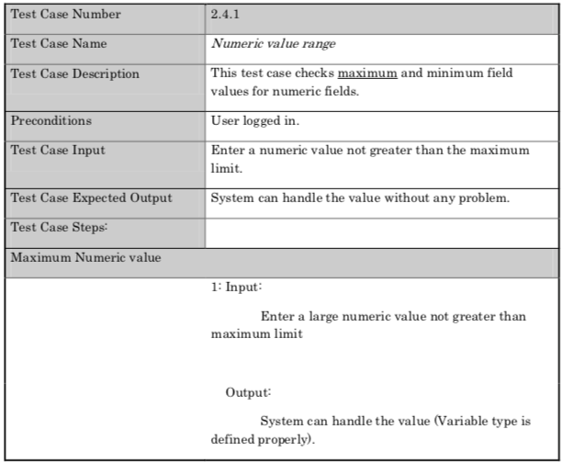

# Task Assign (to each team member)

|  |  |  |  |  |  |  |
| --- | --- | --- | --- | --- | --- | --- |
| Group Name | Project Name | | | | | |
| No | Task name | Description | Start Date | End Date | Member | Self assessment |
| 1 |  |  |  |  |  |  |
| 2 |  |  |  |  |  |  |
| 3 |  |  |  |  |  |  |
| 4 |  |  |  |  |  |  |
| 5 |  |  |  |  |  |  |

# Installation Instructions

< Consistently listing conventions when installing software (Detailed instructions with pictures and notes)>

1. Deployment Diagram

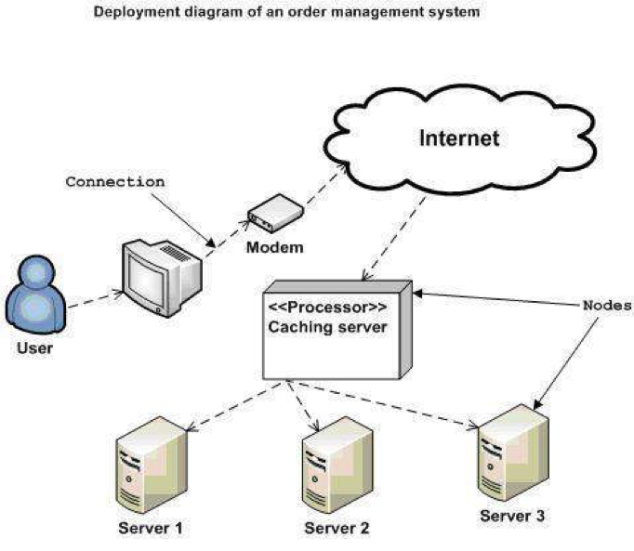

1. Installation steps
   * Database Install
   * Server install
   * Application install

# Appendix

Terms and abbreviations <if available>

<listing terms and abbreviations here>

References <if available >

<List of references here>

Some other issues <if available >

<Results, limitations, experiences, techniques, and other considerations when implementing a project>

# Document format

**Report corver:**

*The cover is printed in blue.*

*With the format as the first page of this document.*

**Paper Size:**

*The report is presented on A4 size paper (210 mm x 297 mm)*

**Top header**

*Left: Logo của VTC Academy*

*Right: Project Name*

*Font: Helvetica Neue (Light) or Arial*

*Font size: 12pt*

**Bottom header**

*Left: Class_Name –Project_Name*

*Right: Page_Number*

*Font: Helvetica Neue (Light) or Arial*

*Font size: 12pt*

**Report Content:**

*Font: Helvetica Neue (Light) or Arial*

*Font size: 12pt*

*Minimum 20 pages*

**Page margin (for A4 size paper)**

*Top: 20 - 25 mm;*

*Bottom: 20 - 25 mm;*

*Left: 30 - 35 mm;*

*Right: 15 - 20 mm;*